 | 12.1.26 Editors - Geometry Nodes Editor - Header - Add Menu - Mesh - Operations
Table of content
Detailed table of content 1
Add menu - Mesh - Operations 5
Dual Mesh 5
Edge Paths to Curves 5
Edge Path to Selection 6
Extrude Mesh 6
Flip Faces 7
Mesh Boolean 8
Mesh to Curve 9
Mesh to Points 9
Mesh to Volume 10
Scale Elements 11
Split Edges 12
Subdivide Mesh 12
Subdivision Surface 12
Triangulate 13

Detailed table of content
Detailed table of content
Detailed table of content 1
Add menu - Mesh - Operations 5
Dual Mesh 5
Inputs 5
Mesh 5
Keep Boundaries 5
Outputs 5
Dual Mesh 5
Edge Paths to Curves 5
Inputs 5
Mesh 5
Start Vertices 6
Next Vertex Index 6
Outputs 6
Curves 6
Edge Path to Selection 6
Inputs 6
Start Vertices 6
Next Vertex Index 6
Outputs 6
Selection 6
Extrude Mesh 6
Inputs 6
Mesh 6
Selection 6
Offset 6
Offset Scale 7
Individual 7
Properties 7
Mode 7
Outputs 7
Mesh 7
Top 7
Side 7
Flip Faces 7
Inputs 7
Mesh 7
Selection 7
Outputs 7
Dual Mesh 7
Mesh Boolean 8
Inputs 8
Geometry 1, 2 8
Self Intersect 8
Hole Tolerant 8
Properties 8
Operation 8
Intersect 8
Union 8
Difference 8
Solver 8
Float 8
Exact 8
Output 8
Geometry 8
Mesh to Curve 9
Inputs 9
Mesh 9
Selection 9
Outputs 9
Curve 9
Mesh to Points 9
Inputs 9
Mesh 9
Selection 9
Position 9
Radius 9
Properties 9
Mode 9
Outputs 10
Curve 10
Mesh to Volume 10
Inputs 10
Mesh 10
Density 10
Voxel Amount / Voxel Size 10
Exterior Bandwidth 10
Interior Bandwidth 10
Properties 10
Resolution 10
Outputs 10
Volume 10
Scale Elements 11
Inputs 11
Geometry 11
Selection 11
Scale 11
Center 11
Axis 11
Properties 11
Domain 11
Scale Mode 11
Outputs 11
Geometry 11
Split Edges 12
Inputs 12
Mesh 12
Selection 12
Outputs 12
Mesh 12
Subdivide Mesh 12
Inputs 12
Geometry 12
Level 12
Outputs 12
Geometry 12
Subdivision Surface 12
Inputs 13
Geometry 13
Level 13
Creases 13
Properties 13
UV Smooth 13
Boundary Smooth 13
Outputs 13
Geometry 13
Triangulate 13
Inputs 13
Geometry 13
Minimum Vertices 13
Properties 14
Quad Method 14
Beauty 14
Fixed 14
Fixed Alternate 14
Shortest Diagonal 14
Polygon Method 14
Beauty 14
Clip 14
Outputs 14
Geometry 14

Add menu - Mesh - Operations
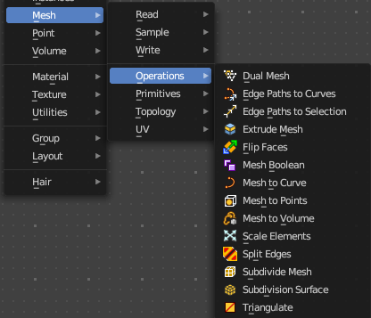
Nodes to modify the mesh geometry.

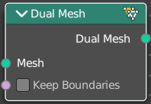
Dual Mesh
The Dual Mesh node calculates the dual of the input mesh. This means that faces get replaced with vertices and vertices with faces.

Inputs

Mesh
The input mesh.

Keep Boundaries
Keep the (non-manifold) boundaries of the mesh intact.

Outputs

Dual Mesh
The output mesh.

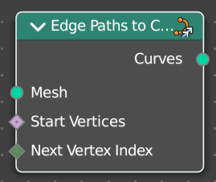
Edge Paths to Curves
Converts Edge Paths to Curves.

Inputs

Mesh
The input mesh.

Start Vertices
The start vertices of the edge path.

Next Vertex Index
The edge path by index.

Outputs

Curves
The output curve.

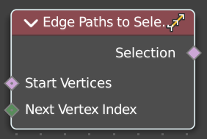
Edge Path to Selection
Calculates an edge path, and converts it to a selectoin

Inputs

Start Vertices
The start vertices of the edge path.

Next Vertex Index
The edge path by index.

Outputs

Selection
The selection

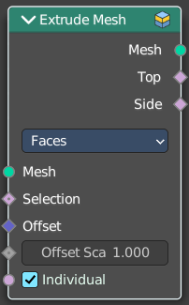
Extrude Mesh
Extrudes out geometry at the selection by a given amount.

Inputs

Mesh
The input mesh.

Selection
A selection of the mesh.

Offset
The offset amount.

Offset Scale
The offset scale. Without an offset this is equal the amount.

Individual
Just Faces mode. Extrude out individual faces.

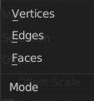
Properties

Mode
What kind of elements to extrude out. Vertices, Edges or Faces.

Outputs

Mesh
The output mesh.

Top
The top elements of the extrusion.

Side
The side elements of the extrusion.

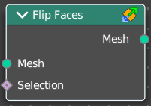
Flip Faces
Flips the winding order of the selected faces.
Blender developers decided not to call it Flip Normals. Since "normals are
derived data, changing them is only a side effect." However, what the node does is in fact to flip the normals.

Inputs

Mesh
The input mesh.

Selection
A selection of the input mesh.

Outputs

Dual Mesh
The output mesh.

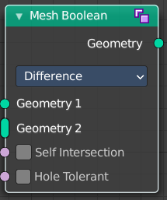
Mesh Boolean
The Boolean Node allows you to cut, subtract, and join the geometry of two inputs. This node offers the same operations as the Boolean modifier.

Inputs

Geometry 1, 2
Standard geometry input.

Self Intersect
Allow self intersection.

Hole Tolerant
Allow holes.

Properties

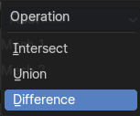
Operation
The boolean operation.

Intersect
Produce a new geometry containing only the volume inside of both geometry 1 and geometry 2.

Union
The two input pieces of geometry are joined, then any interior elements are removed.

Difference
Geometry 2 is subtracted from geometry 1 (everything outside of geometry 2 is kept).

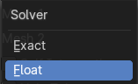
Solver

Float
Simple solver for the best performance. Does not support overlapping geometry.

Exact
Exact solver for the most accurate result.

Output

Geometry
Standard geometry output.

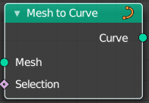
Mesh to Curve
Converts a mesh geometry to a curve geometry.

Inputs

Mesh
Input mesh.

Selection
A selection of the input mesh.

Outputs

Curve
Standard curve output.

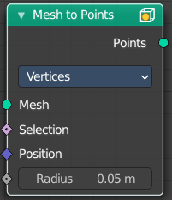
Mesh to Points
Converts a mesh geometry to a point geometry.

Inputs

Mesh
Input mesh.

Selection
A selection of the input mesh.

Position
The position of the points.

Radius
The radius of the points

Properties

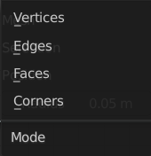
Mode
What geometry to convert to points.

Outputs

Curve
Standard curve output.

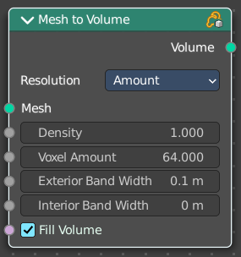
Mesh to Volume
Converts a mesh geometry to a Volume.

Inputs

Mesh
Input mesh.

Density
The density of the volume

Voxel Amount / Voxel Size
The voxel amount / the voxel size

Exterior Bandwidth
How much exterior bandwidth is calculated outside of the mesh. The larger the value the more unnecessary ray calculations happens.

Interior Bandwidth
Where to start the calculation inside of the volume.

Properties

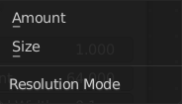
Resolution
How to calculate the volume. Based of the size or based at the amount.

Outputs

Volume
The volume output.

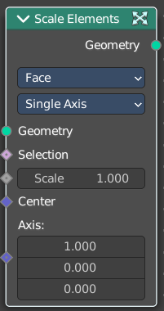
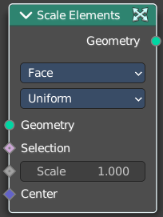
Scale Elements
Allows to scale the selected elements.

Inputs

Geometry
Standard geometry input.

Selection
A selection of the geometry.

Scale
The scale factor

Center
The center of the scaling.

Axis
Scale Mode Single axis only. Scale the selection separately along its single axis.

Properties

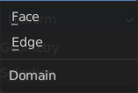
Domain
What kind of elements to scale.

Scale Mode
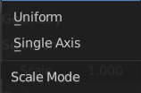
Uniform scales uniformly in all three world coordinates.
Single Axis scales separately in the single axis.

Outputs

Geometry
The output geometry.

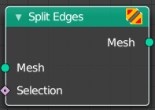
Split Edges
Splits the edges of the geometry.
Note that splitting edges breaks the mesh topology.

Inputs

Mesh
Input mesh.

Selection
A selection of the input mesh.

Outputs

Mesh
Standard Mesh output.

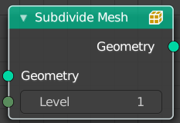
Subdivide Mesh
Subdivides the geometry by a simple division.

Inputs

Geometry
Standard geometry input.

Level
To which degree the geometry will be deformed.

Outputs

Geometry
Standard geometry output.

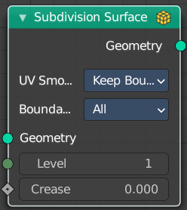
Subdivision Surface
The Subdivision Surface node subdivides the geometry using Catmull-Clark deformation.

Inputs

Geometry
Standard geometry input.

Level
To which degree the geometry will be deformed.

Creases
Control how smooth edges should be with Weighted Edge Creases.

Properties

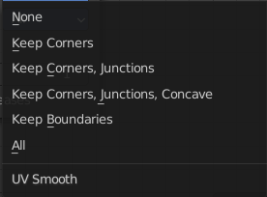
UV Smooth
The methbod to deal with smoothing the UV.

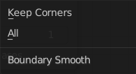
Boundary Smooth
Controls if open boundaries and corners are smooth.

Outputs

Geometry
Standard geometry output.

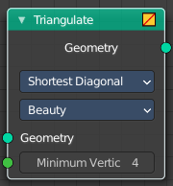
Triangulate
The Triangulate node triangulates all faces in a mesh.

Inputs

Geometry
Standard geometry input.

Minimum Vertices
Minimum number of vertices a face must have to be triangulated. For example, setting this value to 5, will prevent triangulation of Quads and only triangulate N-gons.

Properties

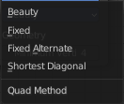
Quad Method
A quad is a polygon with four edges.

Beauty
Split the quads in nice triangles, slower method.

Fixed
Split the quads on their 1st and 3rd vertices.

Fixed Alternate
Split the quads on their 2nd and 4th vertices.

Shortest Diagonal
Split the quads based on the diagonal distance between their vertices.

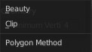
Polygon Method
Meant are N-Gons. Faces with more than four edges. Tris, Quads and N-Gons are all Polygons.

Beauty
Arrange the new triangles nicely, slower method.

Clip
Split the polygons using an ear-clipping algorithm (gives similar results to the tessellation used for the viewport rendering).

Outputs

Geometry
Standard geometry output.

